***KIDS ACTIVITIES WORKSHEETS***

***USING IN ORGANIZATION***

***ZAINAB REHABILITATION CENTRE***

*Here are few worksheets that are used by organization and their teachers/therapist in order to improve their basic knowledge*

*Following are the five modules that we are using to create interactive games that not only increase their knowledge but also improve their basic inabilities that is a major cause*

*(these pictures are downloaded as original worksheets isn’t provided by the organization yet)*

*VISUAL VOCAB BUILDER*

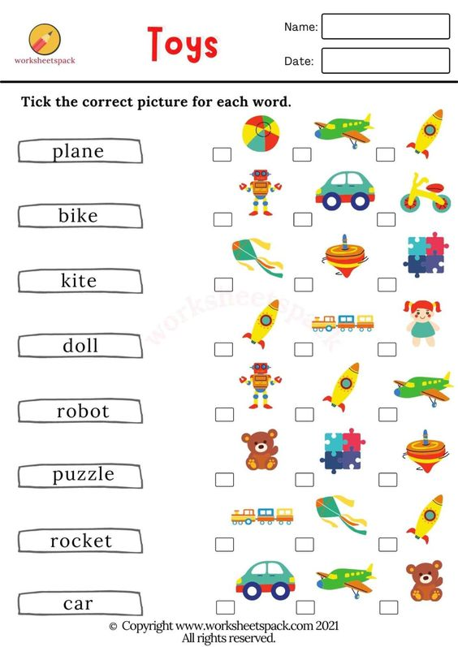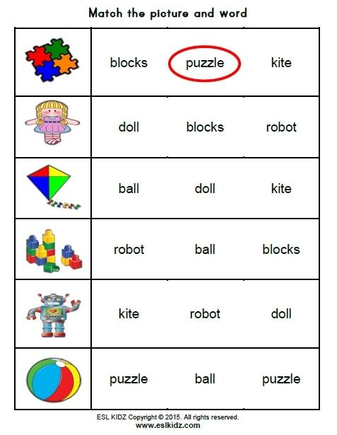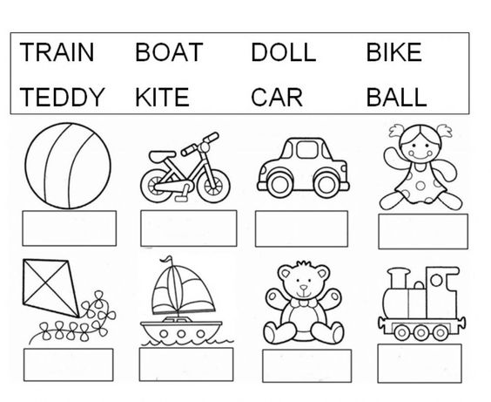

*COUNT WITH ME*

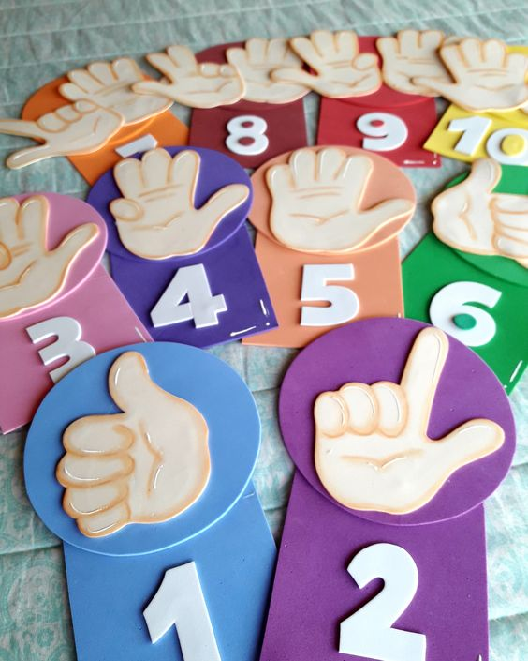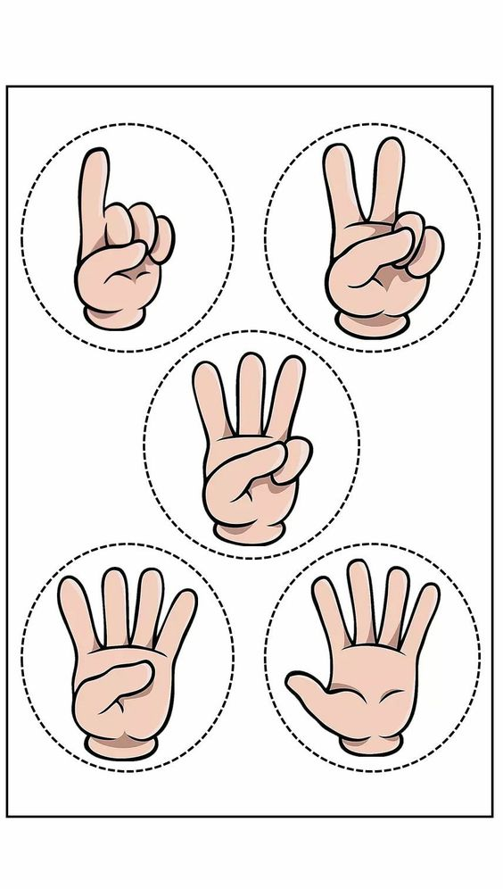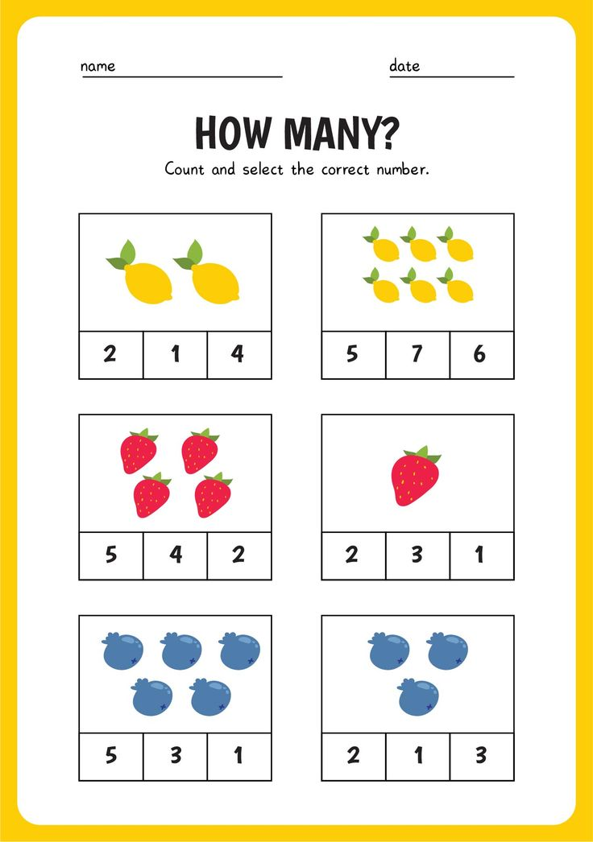

*ONE PIECE HERE*

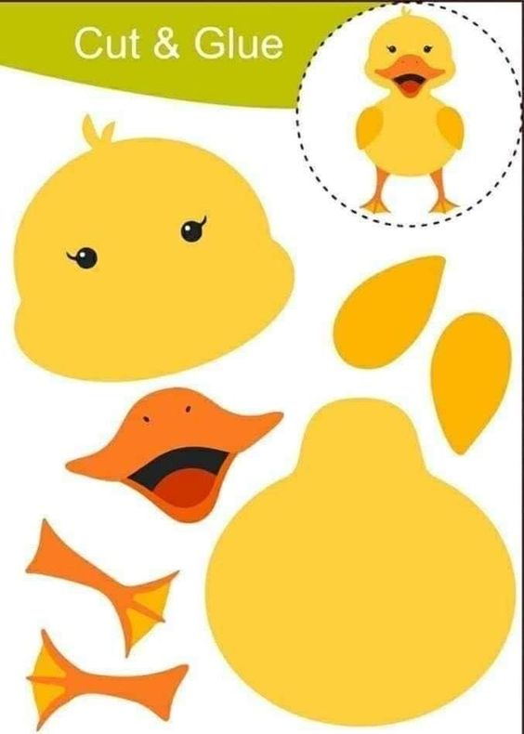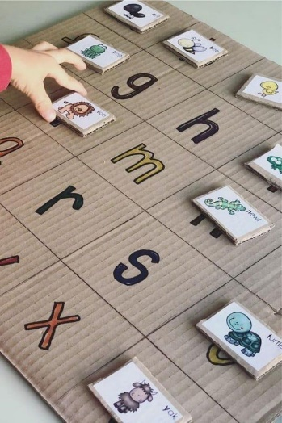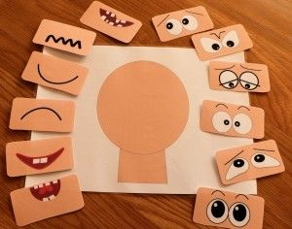

*FLIP THE CARD*

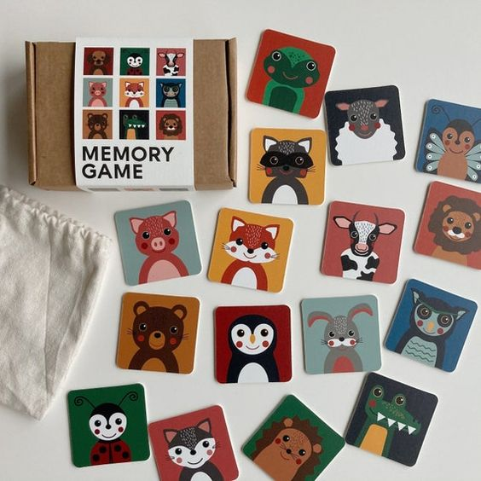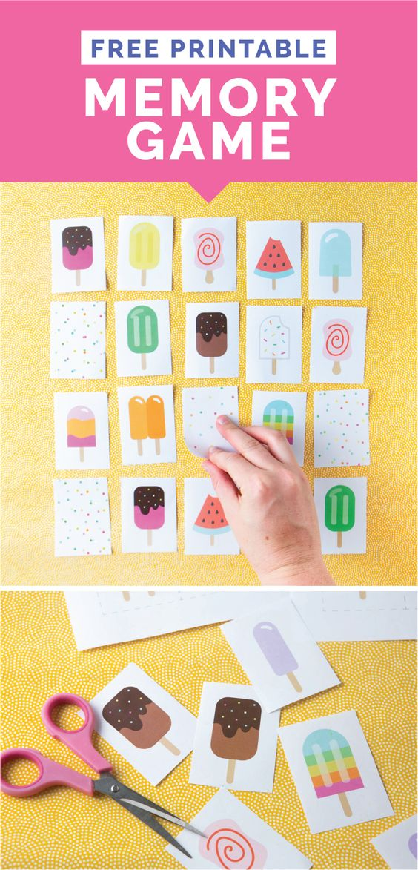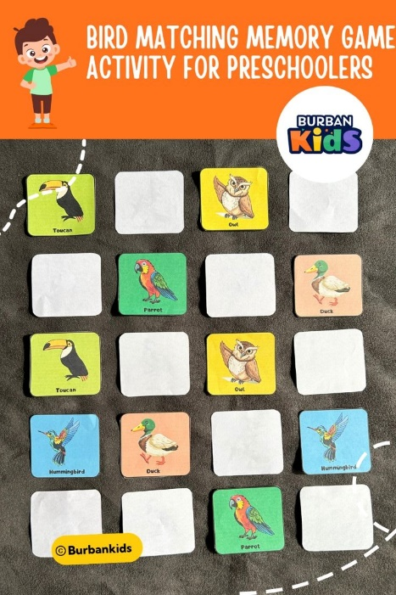

*LETS COLOR IT*

